**inSight 2017**

**Department : Hostel Office**

**Problem Title : Digital hostel residents’ record and complaint management**

**Problem Code : PS01**

**Problem Description :**

Every year there are large numbers of students opting to reside in the hostels. It is a very difficult task to maintain and search manual records for the details of these students. If such software solutions can be developed enabling the hostel department with the features mentioned below, it would reduce severe amount of man power and time.

Features the system should include:

* Provisions to add and modify details of the students (including personal details, academic details, room number, hostel block etc.)
* Provisions of searching of records based on any of the fields as mentioned above.
* Registering of complaint by the students. They should also be able to track their complaint status.

**Any more innovative features are welcome and would attract additional points**.

Note: The solutions can include webapps, stand-alone windows systems, android apps etc.

**Proposed solution:**

Here we can solve this problem by using programming language such as C, C++, JAVA etc. But we use C++ program in CodeBlocks IDE. Firstly we store all the manual record details of the students who are registered for hostel department and store it in a file.

We recursively ask the user what has to be done ( to check the particular student record, to edit the details, to add new student etc). Also we perform the searching operation (to search whether the following student is present or not , including the search based on personal details, academic details, room number, hostel block in one function).

We also give choice for the students whose have registered in hostel for registering of their complaints. And give proper status for their complaint, if it has been corrected or not in their record itself, so the student is allowed to see his status of complaint by logging in with his password, so that he can maintain some privacy.

1. We can create various categories of hostel rooms and create blocks and floors with details.
2. We can register students, staff, guest, separately .
3. We can capture the profile of students and maintain attendance records with entry and exit timings.
4. We can allocate rooms automatically based on number of occupants in each room.
5. Manage hostel fees including deposit expenses and refunds.
6. Delete the student record from the data base upon vacation.
7. Access student information including miss joining , change and discontinuation.
8. We can generate reports on student information, discipline information, warden information, miss information, fee collection.

**Technology Stack :**

1. **Operating System:** Windows 95/98/XP.
2. Oracle or DBMS for Database.
3. C++ for coding,developing the software.

**Use Case:**

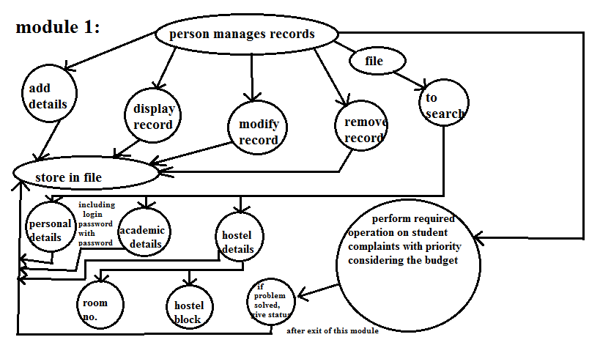

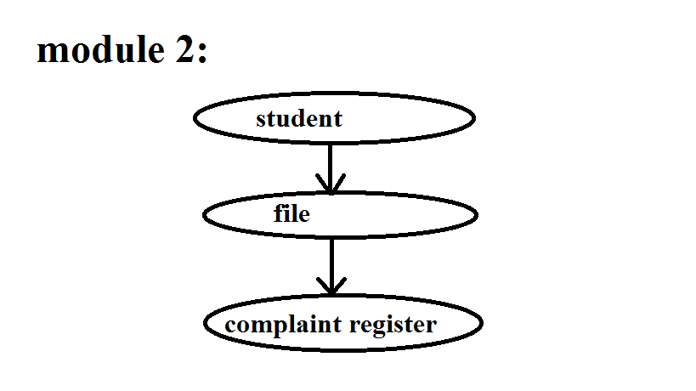

**Team Members details:**

|  |  |  |  |  |
| --- | --- | --- | --- | --- |
| **Role** | **Name** | **USN** | **Email id** | **Phone no.** |
| Team Leader | HARSHA.K | 1SI15IS018 | harshaharshu64@gmail.com | 9482790773 |
| Team Member 1 | NISCHITHA.S.KATTA | 1SI15IS034 | nischithakatta@gmail.com | 9844960541 |
| Team Member 2 | KAMAKSHI.K.R | 1SI15IS021 | kamakshimullangi@gmail.com | 9449602781 |